**Audit Tools Deployment Guide**

Thomas Manuel Ortiz, Ph.D., P.E.

Last Updated on January 17, 2019

Testing of the tools is conducted from K:\Audit_Tools (\\gload\devtest\integration\Audit_Tools).

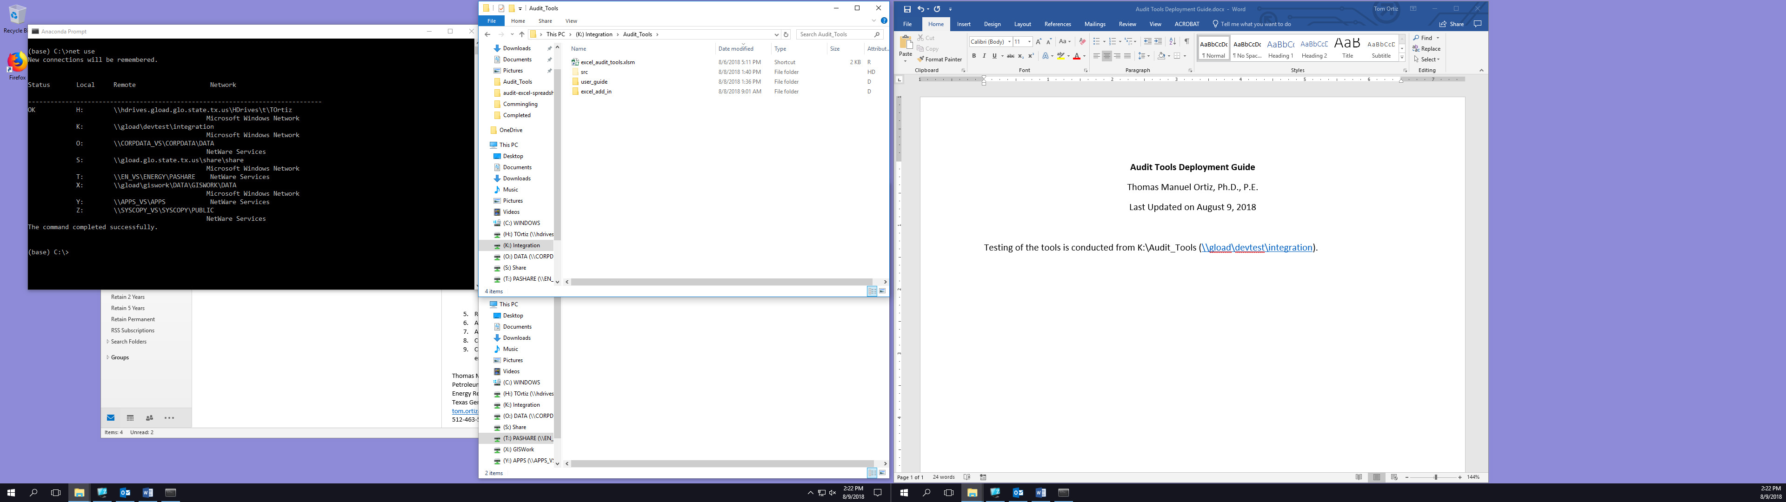

The deployment location is O:\AUDIT_TOOLS (\\CORPDATA_VS\CORPDATA\DATA\AUDIT_TOOLS). If there are existing files in the deployment location, delete them before deploying the new files.

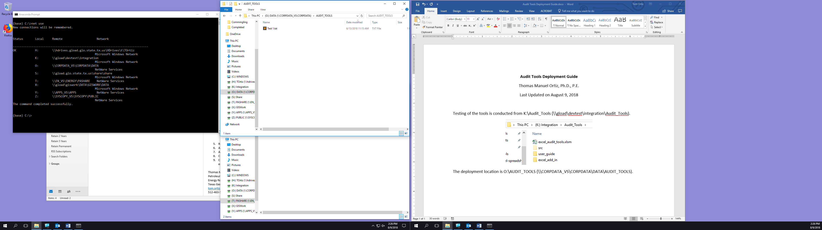

Then, copy everything in K:\Audit_Tools to O:\AUDIT_TOOLS *except* for the spreadsheet shortcut excel_audit_tools.xlsm. The shortcut must be recreated in order to ensure that it points to the correct location.



Navigate to O:\AUDIT_TOOLS\src. Select and copy the file excel_audit_tools.xlsm. Then navigate back to O:\AUDIT_TOOLS, choose Paste Shortcut, and then rename the new shortcut excel_audit_tools.xlsm.

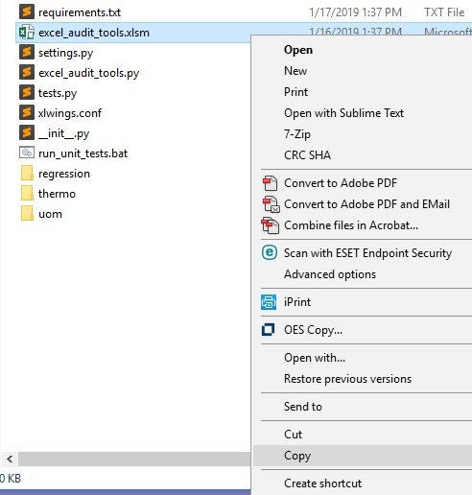

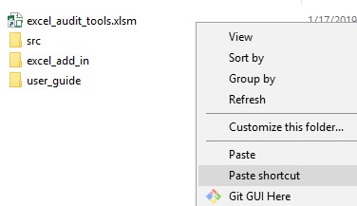

Open the file src\xlwings.conf and change the value of the INTERPRETER configuration variable to correspond to the deployed location, i.e. O:\AUDIT_TOOLS\src\miniconda3\pythonw.exe .

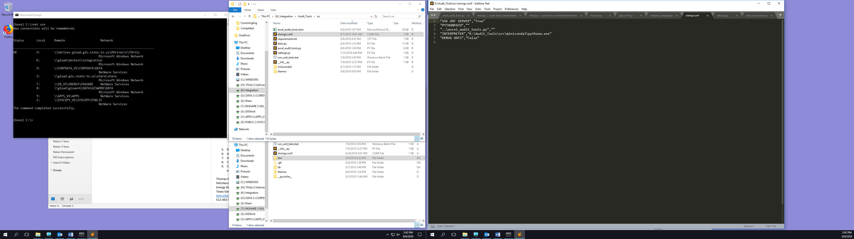

Finally, be sure to set the Read Only attribute for all files deployed to O:\AUDIT_TOOLS.